Report for



By: Intellij System Solution Sdn. Bhd.

**1.0 Introduction**

|  |  |
| --- | --- |
| **General Information** | **Response** |
| Name of Candidate: | MJ Carmelotes |
| Apply Position: | .Net Developer |
| Date of Submission : | August 29, 2017 |
| Github repository link: | https://github.com/mjcarmelotes02/SodingTask |

**2.0 How it Works**

# Soding Task

A simple system (web based) to implement a Task CRUD app using C# programming language.

Allows you to keep track of things you need to do in a simple way, paper free. Users can manage and view tasks.

Cool features are as follows:

1. **Listing.** All tasks can be viewed and are displayed. From here users can navigate to create, update, view and delete task.
2. **Create Task.** App users can simply add a task. Just add name and description.
3. **Update Task.** App users can simply modify a task anytime.
4. **Delete Task.** App users can remove tasks if they want to.
5. **Details.** App users can view details of a given task.

Form Fields/Validations:

1. **Name** - name for given task. This is a required field with allowed maximum of 30 characters.
2. **Description** – describes the task. This field allows maximum of 100 characters
3. **Date Created** – date which the task is created
4. **Date Updated** - date which a task has been modified

**3.0 Screenshots**

Listing Page

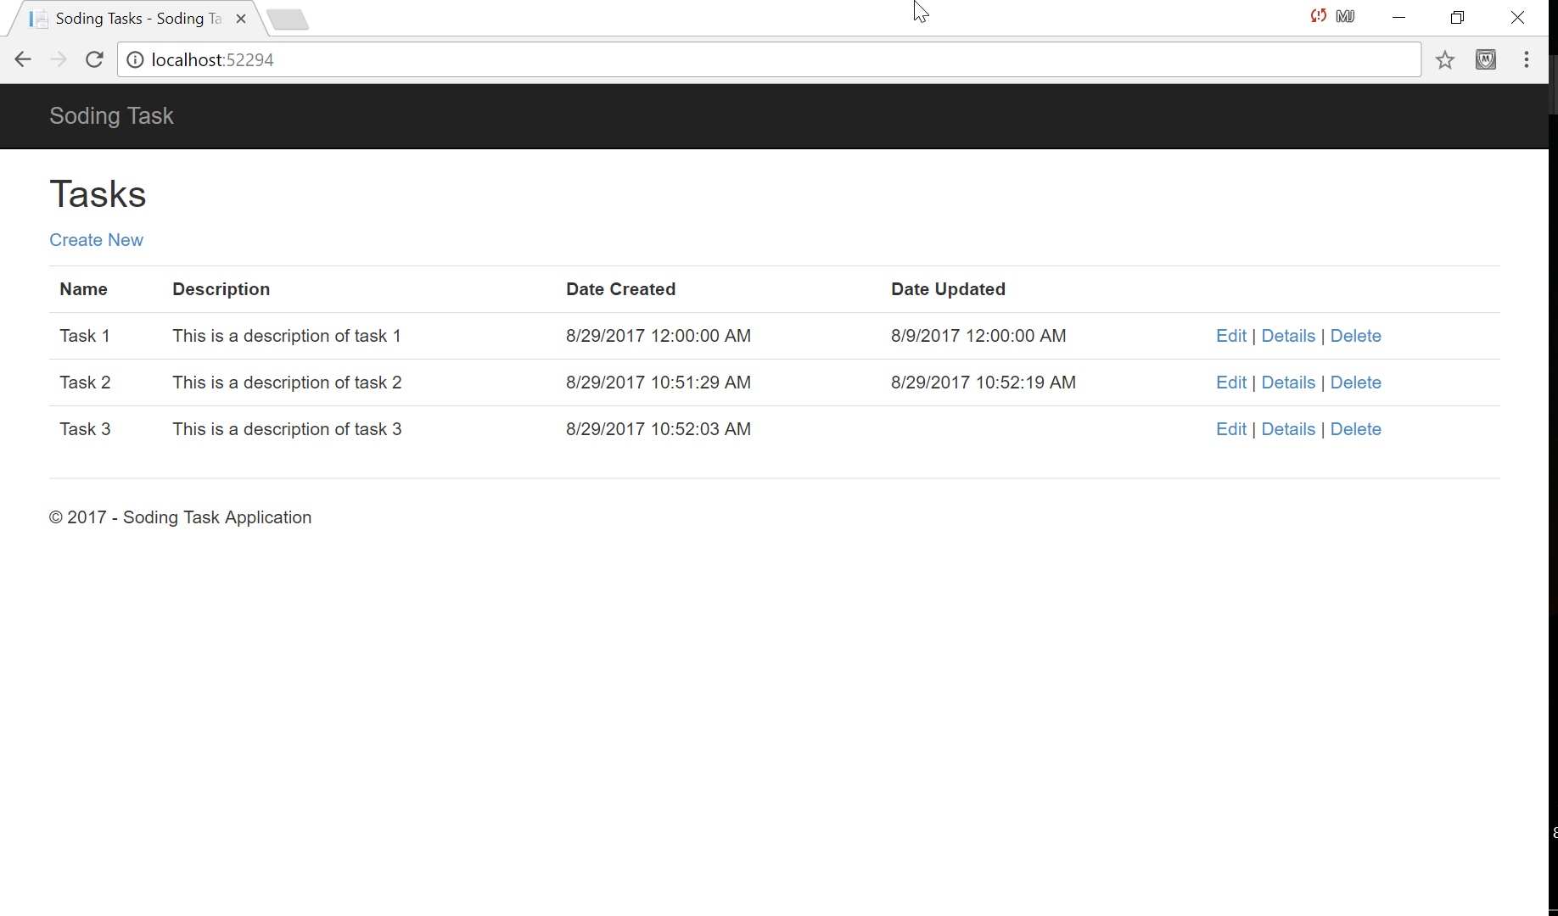

Note: From here, user can navigate to different pages, e.g. create, update, delete, display task.

­

Create Task Page

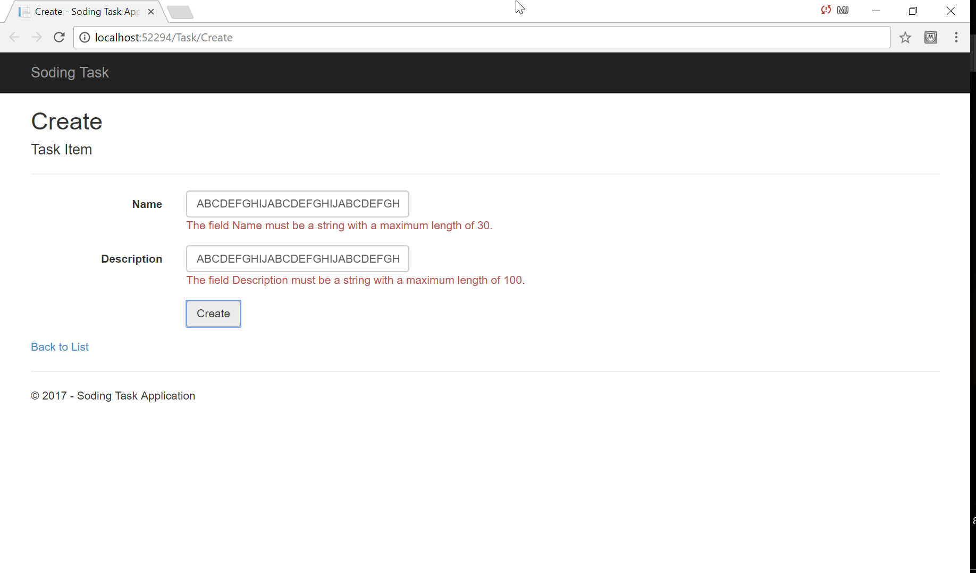

Note: For list of validations please see How it Works > Form Fields & Validations

Update Task Page

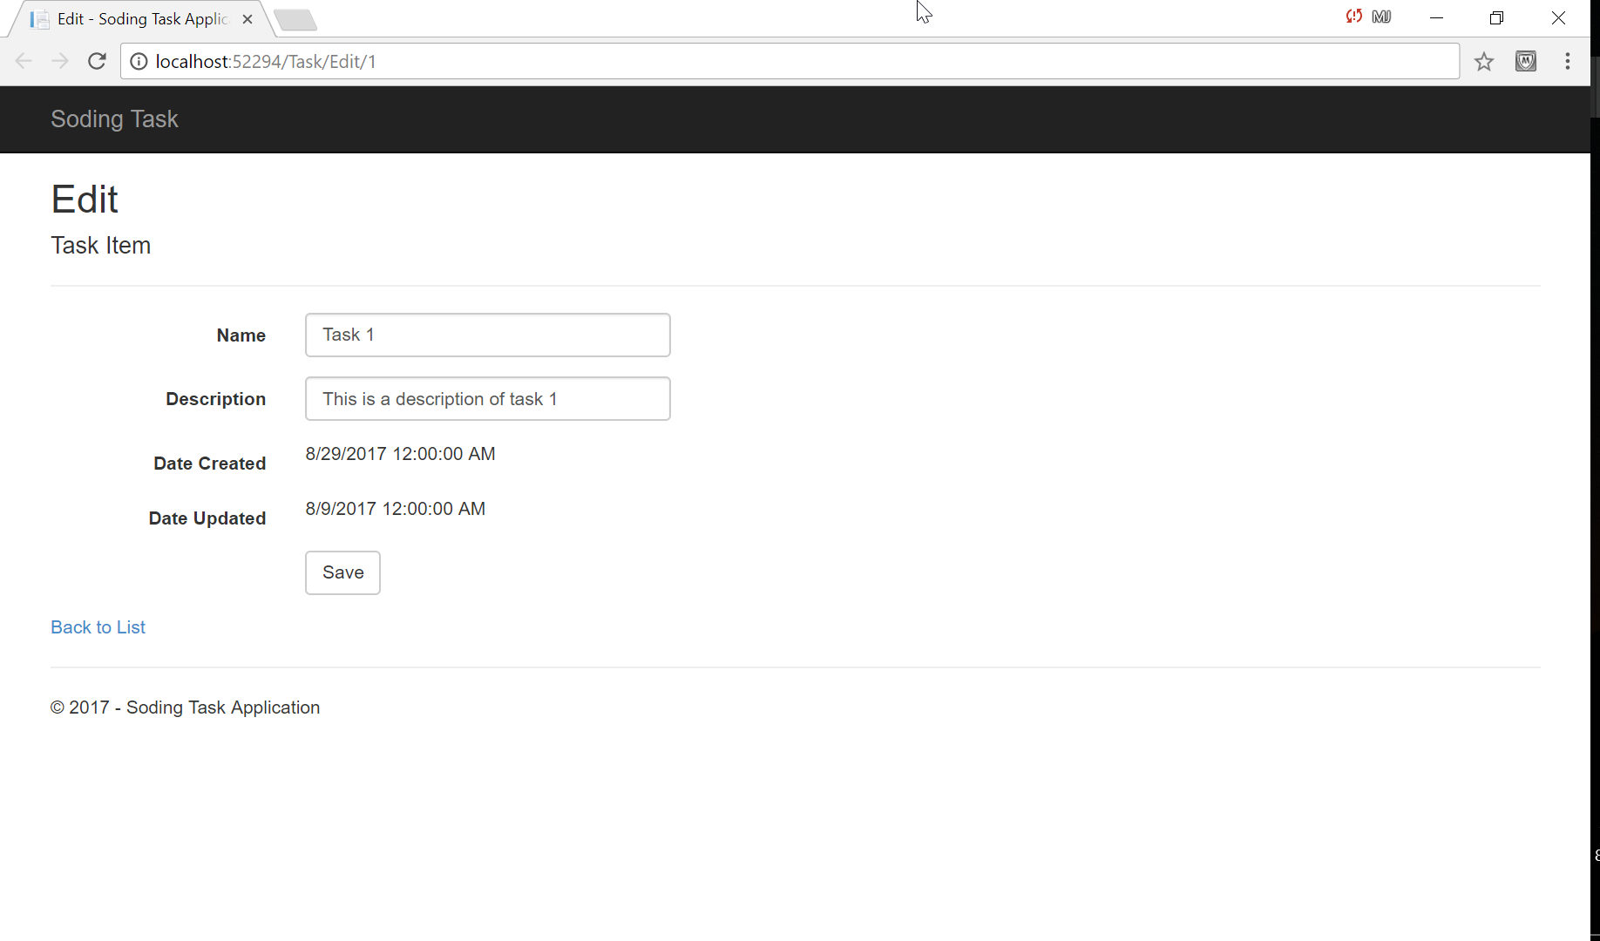

Note: For list of validations please see How it Works > Form Fields & Validations

Delete Task Page

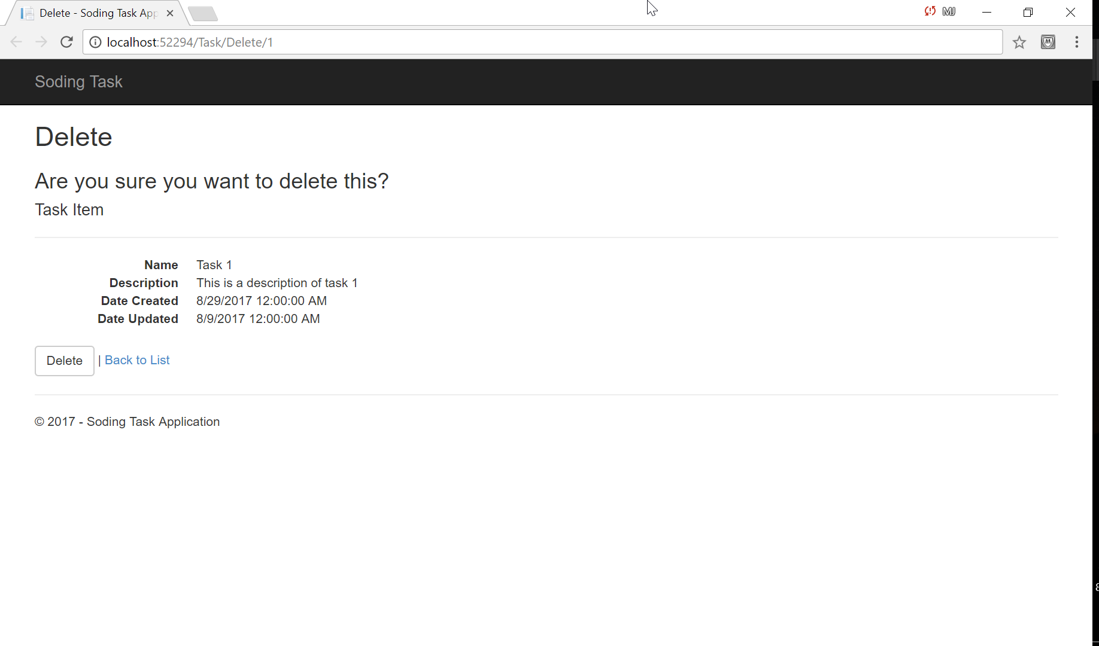

Details Page

